# Conflict Scenario

## **Review**

### Interpersonal Conflict Management Styles

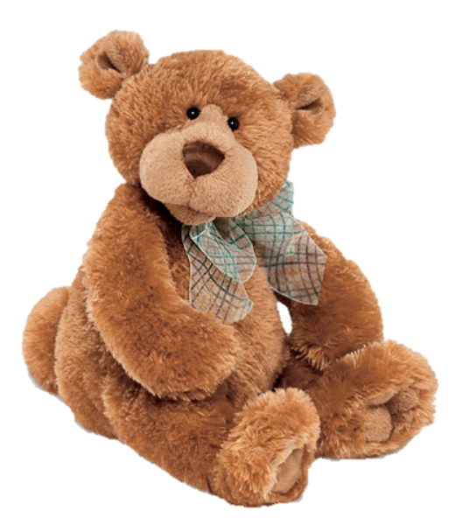

[CC 2.0 BY Matthew](https://www.flickr.com/photos/falcon1961/3304306800/)



[CC SA 3.0 Unported BY Jonathan Zander](https://en.wikipedia.org/wiki/File:Florida_Box_Turtle_Digon3.jpg)



[CC 3.0 BY Superawesomevectors](https://superawesomevectors.deviantart.com/art/Shark-Cartoon-Free-Vector-Illustration-643399222)



[CC0](https://pixabay.com/en/urban-lost-hiding-afraid-1002149/)

Low to High Concern for Other

Concern for Self



CC SA 2.0 Generic BY [Carine06 from UK](https://commons.wikimedia.org/wiki/File:Flickr_-_Carine06_-_%22I_give_up.%22.jpg)



CC 2.0 BY [Zabara Alexander](https://www.flickr.com/photos/zabara_tango/6955720271)



[CC0](https://commons.wikimedia.org/wiki/File:US_Army_53525_Soldiers_compete_in_Tae_Kwon_Do_tournament_for_Warrior_Country_level.jpg)

### **Interpersonal Conflict Resolution**

The following diagram shows a process that can be followed when trying to resolve interpersonal conflict.

### Listening

A considerable proportion of our communication involves listening, yet little attention is devoted to improving listening. HURIER is an acronym for tips that can be used to improve listening.

### “I” Phrases for Conflict Resolution

The “I” phrase is used during conflict resolutions to avoid attacking others. Open the conversation with a statement in first person, passive voice: “I feel … when … because … I would like …”

Adapted from (Dwyer 2012, p. 40)

## **Student Name and ID:** Kathryn Linderberg 12194396

## **Student Name and ID:** Thomas S0287944

## **Scenario**

Find a partner. Read the scenario below. Choose one partner to be Joe Bloggs, and the other to be Jane Doe. Together, answer the following to help prepare you for the role play.

## **Scenario: Joe did not complete a task by the deadline**

Joe and Jane are working on a report that is due today. Joe was assigned the task of writing the executive summary. Unfortunately, Joe has not completed the task.

What is the most appropriate conflict management strategy for Jane to use in this situation? (Choose one)

Compete/Force

Compromise

Avoid/Withdraw

Collaborate/Confront

Accommodate/Smooth

Why did you choose the above conflict management strategy?

To allow Joe the opportunity to explain why he hadn’t completed the task, and then have a smooth conversation with Jane.

### **Listen and Understand**

How could Jane start the conversation?

Hey Joe, How’s the executive summary report coming along?

Describe the purpose of the discussion. Describe the conflict. What questions could Jane ask to determine Joe’s perspective of the situation?

Find a resolution to get the executive summary. The conflict is the executive summary. Jane could ask if there are any issues or reasons why the summary hasn’t been completed.

Write sentences that features the “I” phrase, such as in the example below:

“I feel *[your feeling]* when *[their behaviour]* because *[effects on you]*. I would like *[alternative behaviour]*”.

I feel angry and upset when the works not being completed because it effects the whole process of us completing the work. I would like if you do have any concerns or not understanding your part of the report, to please discuss with me, so we can work through it together.

Invent a reason why Joe did not complete the executive summary by the deadline.

I did not understand what was required of me to complete the task, as I don’t understand the Tables, therefore that was the reason my executive summary was not completed by the deadline.

How could Jane paraphrase Joe’s reason for missing the deadline to ensure that she understands Joe’s perspective?

I can totally understand that you might not see how to read the tables, however, it would have been helpful if you could have come to me earlier, that we could have worked through the scenario together to come up with a resolution and have the task completed by the deadline.

Jane is repeating what Joe has said in his previous statement, so that it shows that she is listening and understanding what Joe has said

### **Empathise**

Now that Jane understands Joe’s perspective, how could Jane empathise with Joe? Write a response that shows that Jane identifies with Joe’s emotions.

Jane can empathise with Joe, by showing that she understands and saying that it’s ok. It’s happened this time, however, in future, this is what I’d like you to do if the same situation arises. Jane can see that Joe might be feeling intimidated or embarrassed by the issue that he did not understand the work.

### **Apologise**

Include an apology if it is appropriate.

I don’t think this would warrant an apology, as it can’t be helped if he didn’t know how to read the tables. He may apologise for not having completed the summary in the given time frame.

### **Offer Solution**

What question could Jane ask to help build Joe’s involvement with potential solutions?

What parts of the table are you not understanding and what can I do to help assist you understand the table, so that you might complete the work. (Jane and Joe have come to a mutual agreement that Joe will complete the work once he understands the situation)

Come up with a way for Jane and Joe to settle on a solution.

Setup an appropriate time for both parties, via Zoom.

### **Resolution**

How could Jane resolve the conflict? Jane needs to ensure that Joe agrees. Write a response that outlines appreciation for the solution.

I would ask Joe what he doesn’t understand, explain it to him, so he does have an understanding, and then get Joe, if he agrees to it, complete the executive summary work. Both parties find a mutual appreciation, because Joe grasps an understanding of what he didn’t know before, without judgement, and Jane appreciates that the work is going to be completed.

### **Reconciliation**

How could Joe reconcile the relationship and let Jane know that she is important to him?

Joe would reconcile the relationship, by completing the work, as this would let Jane know that he values his position. Joe could offer a thank you for the assistance and buy Jane some chocolates as a thank you for her understanding.

How can Jane let Joe know she is listening while Joe is talking?

Jane can let Joe know by keeping eye contact, non verbal cues and just acknowledging his conversation.

What could Jane do if Joe started to withdraw from the conflict at any stage?

If Joe withdrew and felt uncomfortable Jane might suggest speaking to someone else, or introduce a third person for a non-biased opinion.